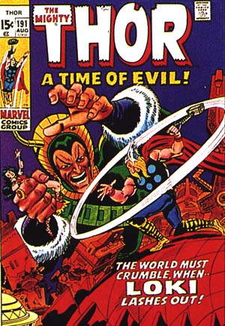
Loki makes a mistake
One night Loki couldn´t sleep. He took big scissors and went to Bilskirner, the castle of Thor. Thor wasn´t home but his wife Sif was, she was sleeping. Loki cut all of her gold colored hair, when he was finished her head was all hairless. Loki took her hair and put it inside his coat and climbed out of the window, but he dropped one of his shoes. When Thor came home he saw Sif without any hair, he got furious and when he saw the shoe he understood who had done it. Boiling by rage Thor went to Loki. With his hand he took Loki´s neck and shook him so hard his eyes almost dropped out of his head. Loki promised that Sif would get beautiful long gold colored hair again if Thor would let him go, and Odin, Frej and Thor would also receive gifts, Loki got one night and one day to do this. He went to Svartalvaheim where the dwarfs lived, they were very good craftsmen and could do the most amazing things. In two hours the dwarfs had made the most beautiful golden hair the world had ever seen, the spear Gungner to Odin and the ship Skidbladner to Freyr. Loki now bet with the dwarf Brok that he couldn´t do as nice things as the others.
“You will get my head on a plate if you can,” Loki said.
“Oh yes I can,” Brok said and began to work.
At sundown Brok had made, Thor´s hammer Mjölner, the goldenring Draupner and a pig called Gyllenborst.
Loki and Brok hurried to Valhalla, there they gave the gifts, Odin got his spear Gungner and the goldering Draupner that every ninth night dropped nine equal big rings. Freyr got the ship Skidbladner and the pig Gyllenborst. Thor got the hammer Mjölner that never misses its target and always came back to the owners hand after been thrown and Sif got her hair back.
Brok now demanded to get Loki´s head on a plate. But Loki said that he only had right to the head and not the neck therefore he couldn’t cut his head off. Brok felt fooled. To punish Loki Brok sewed Loki´s mouth together, it took months for Loki to talk again.

When Trym Stole Thor’s Hammer
One morning when Thor woke up the hammer was gone. He talked to Loki, the smartest one in Asgard to get some advice. Loki thought he knew who the thief was, he went to Freyja and asked for her feather coat so he could fly to the Giant Trym.
“I know it’s you that stole Thor’s hammer,” Loki said.
“Yes and I have hidden the hammer 8 miles under the earth. If you bring Freyja to me as a wife you will get the hammer back.”
Loki flew back to Asgard and told Thor what Trym had said. Thor got angry, but Freyja got more angry and refused to get married to Trym. Without Thor’s hammer the Gods weren’t safe, the Giants could easily attack. Odin called the Gods to a meeting, together they had to solve the problem. “We have to be clever,” Heimdall said.
“If you Thor get dressed as a bride, I’m sure they will bring the hammer to us,” Loki said.
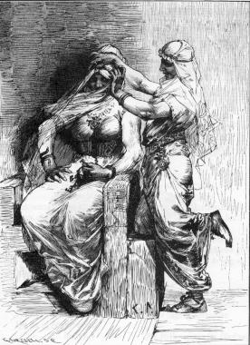
Thor refused at first but he realized that that was the best thing to do, the hammer has to be returned. They got Thor to get into a long dress, his big legs was not to be shown, on the head they put a hat and around his neck they put Freyja’s necklace. The last thing was a white bride dress. When Loki saw Thor he laughed and made fun of him but Thor made him come along as a bridesmaid. The goats were set in front of the carriage and at nightfall they were at Trym’s. The Giants brought a lot of food to celebrate the wedding. Thor himself ate a whole ox, eight salmons and 300 liters of beer. Trym thought the bride ate too much and Loki said,
“Freyja hasn’t eaten for eight days because she have been longing for you.”
Trym was satisfied with that answer and tried to kiss the bride, but when he saw the bride’s eyes he got terrified.
“She hasn’t been sleeping for eight nights of wanting to see you,” Loki said.
Then Trym thought it was time for the couple to get wed. “Get the hammer and put in the brides knee,” Trym ordered.
When Thor got the hammer in his hand he felt the muscles grow, and with a terrible blow he killed Trym and after that the whole family of Trym. The Gods were happy and Thor and Loki returned to Asgard.

