Name:

Multiple Choice
Act I
_____ 1. “A pair of star crossed lovers take their life…” is a passage from the prologue. The term “star- crossed levers” means:
a. Romeo and Juliet are destined by fate not to have a happy life
b. Romeo compared Juliet’s eyes to stars
c. Romeo and Juliet used the stars to find each other
d. Their getting together was predicted by the stars
_____ 2. Benvolio tries to make peace during the street brawl but is stopped by:
a. the Prince b. Tybalt c. someone biting his thumb at him d. Romeo
_____ 3. At the beginning of the play, Romeo is sad because:
a. Tybalt vowed to kill him b. Rosalyn will not return his love c. Juliet will not return
his love d. because of the big fight
_____ 4. At the party,
a. Tybalt recognizes Romeo b. Lord Capulet tells Tybalt to kill Romeo c. Mercutio gets
drunk b. Benvolio falls in love with Juliet

Act II

_____ 5. Juliet professes her love for Romeo because:
a. she is mad at her father b. she is scared that since he is a Montague, he will hate her
c. she is unaware that he is in the garden listening d. Romeo tells her he loves her first
_____ 6. “Wherefore art thou Romeo?” means:
a. Why are you Romeo? b. Who is Romeo? c. Where are you Romeo? d. Yo! What sup?
_____ 7. That night they agree to:
a. keep their love a secret b. get married c. kill Tybalt d. run away together

Act III

_____ 8. Tybalt kills Mercutio because:
a. Mercutio stabbed his brother b. Romeo got in the way c. Tybalt is just a jerk like that
_____ 9. Romeo’s punishment is:
a. death b. banishment c. a public whipping d. breaking the marriage between Juliet and him
_____ 10. Juliet finds out that:
a. she is to marry Paris b. Tybalt really loved her c. Romeo is dead (but he’s not, really)
d. the nurse has betrayed her to her parents
Act IV

_____ 11. The friar gives Juliet:
a. a love letter from Romeo b. a dagger to kill herself with c. a lecture on how she should
marry Paris d. a poison-like potion
_____ 12. Lord Capulet changes plans when he:
a. sends an assassin to kill Romeo b. challenges Lord Montague to a sword fight
c. when plots against the prince d. accuses the friar of helping Juliet e. moves the wedding
to Wednesday

Act V

_____ 13. Romeo goes to the apothecary because:
a. he wants to buy some poison b. he is expecting a letter from the friar c. he is expecting
to hear news from Verona d. what the heck is an apothecary?
_____ 14. Paris attacks Romeo because:
a. he knows Romeo loves Juliet b. he thinks Romeo is about to make sure Juliet is really dead
c. he thinks Romeo is a thief d. he thinks Romeo is out to further disgrace the Capulets by
vandalizing the tomb.
_____ 15. In the end:
a. the Prince kills everyone b. the Capulets leave Verona c. The Montagues attack the
Capulets d. The Montagues and Capulets make peace

Literary Term Matching:
a. Situational Irony b. Dramatic Irony c. Aside d. Soliloquy e. Couplet

_____ 16. When people talk on stage, but other actors on stage can’t hear them; a stage whisper

_____ 17. We know Juliet is not dead, but Romeo doesn’t

_____ 18. When someone talks on stage by themselves (or at least thinks they are by themselves)

_____ 19. Two lines that are back to back and rhyme

One of the last lines is from the Prince. He says: “Some shall be pardoned and some punished.”

Of the following characters, who is the most responsible, why, and how should they be punished? You may pick a different character than what I list here and remember that you points mostly come from your reasoning on why they are responsible.
Friar Laurence Lord Montague Lord Capulet Nurse Prince Apothecary

Fill in the characters listed in the middle into their correct places:

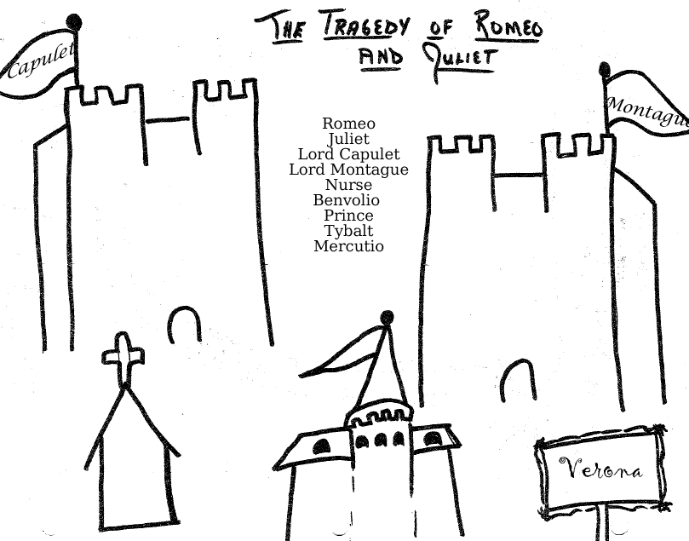

Quotes – identify who said the quote and what it means

Quote | Who said it | What it means/what is going on
“What, drawn and talk of peace? I hate the word
As I hate hell, all Montagues, and thee.”

”In one respect I’ll they assistant be;
For this alliance may so happy prove
To turn your household’s rancor to pure love.”
“Ask for me tomorrow and you shall find me a grave man.”

“O sweet my mother, cast me not away!
Delay this marriage for a month, a week;”

“Thy drugs are quick. Thus with a kiss I die”

Write down FOUR things that happen on each day:

Day 1  Sunday | Day 2  Monday | Day 3  Tuesday | Day 4  Wednesday
1.  2.  3.  4. | 1.  2.  3.  4. | 1.  2.  3.  4. | 1.  2.  3.  4.

Extra Credit: This is from a manga version of Romeo and Juliet. Using only this panel, identify the speaker.

